Topographic Map WebQuest

Use the links below to help answer the questions
https://www.nps.gov/webrangers/activities/readingmap/readingmap.swf

http://adventure.howstuffworks.com/outdoor-activities/hiking/how-to-read-a-topographic-map.htm

http://articles.extension.org/pages/9695/topography-and-understanding-topographic-maps

http://depthome.brooklyn.cuny.edu/geology/core332/maps3.htm

- What is topography?

- What do topographic maps show us?

- How were topographic maps made before technology? How is it different from how topographic maps are made now?

- What are topographic maps used for?

- What do the following colors on topographic maps represent?
  - Green -
  - Blue -
  - Grey/red -
  - Black -
- What are contour lines?

- What do lines on contour maps represent?

- What is the space between contour lines called?

- What is every fifth contour line called?

- What does the spacing of contour lines tell us about the slope of the land?

- Why would a hiker want to use a topographic map?

- Use the internet, or your textbook to do the following:
  - Draw a topographic map and include the following:
    - Contour lines (must have at least 10) , index contour, contour interval, a hill, a depression, a river, 1 steep slope, and 1 gentle slope

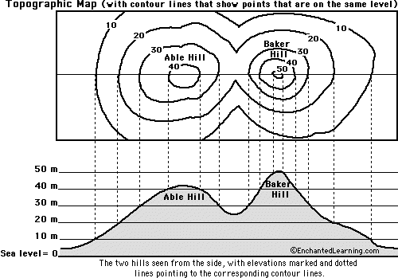

- What point of view is the top map? ____________________________

- Approximately how tall is Able Hill? ___________________________

- Approximately how tall is Baker Hill? ___________________________

- Which mountain is taller, and by about how much? ________________________

- How many meters of elevation are there between contour lines on the topographic map? ___________________________

- Which mountain has steeper slopes? ________________________

- How can you tell this mountain has steeper slopes?

- Are the contour lines closer together on Able Hill or Baker Hill?___________________________

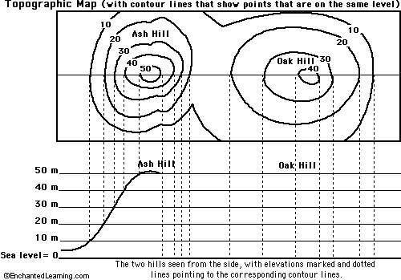

- Color the elevations on the topographic map as follows. Red: 50m and higher, Orange: 40-50m, Yellow: 30-40m, Light green: 20-30m, Dark green: 10-20m, Purple: 0-10m.

- Finish the mountain diagram below the topographic map, completing Oak Hill and drawing Ash Hill with proper elevations.

- Approximately how tall is Ash Hill?

- Approximately how tall is Oak Hill?

- Which mountain is taller?

- How many meters of elevation are there between contour lines on the topographic map?

- Are the contour lines closer together on Ash Hill or Oak Hill?

- Which mountain has steeper slopes?

