MATTER | - Anything that has mass and takes up space  - Air and water IS matter  - Light, heat, sound are NOT matter
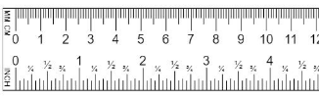  LENGTH | - Measurement from one end to another.  - Distance  - Measured using a ruler  - Units: meter (m)
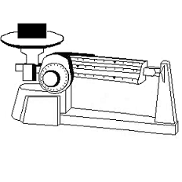  MASS | - The amount of matter in an object  - Units: gram (g)  - Mass is different than weight. Weight changes depending on gravity (the more gravity on an object, the more it weighs)
VOLUME | - The amount of space an object takes up  - How big or small something is  - Units: cm³ or mL  - 2 ways to find volume:  - Regular object use formula V=LxWxH (ruler)  - Irregular object use water displacement (graduated cylinder)  - Water displacement:  - measure out a certain amount of water in a graduated cylinder (any amount of water), then read the BOTTOM OF MENISCUS  - Drop the object into the graduated cylinder  - Read the new volume  - Subtract the original volume from the new volume (or final reading-initial reading) and you will get the volume of just the object
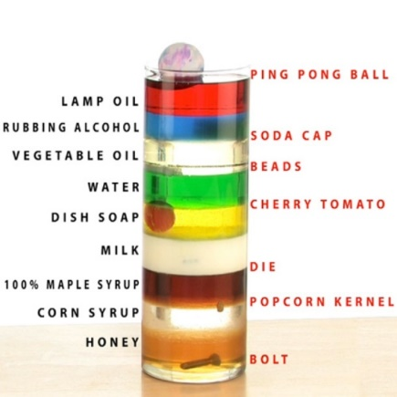  DENSITY | - The ratio of mass to volume  - How much matter, or “stuff” is packed into a given volume  - Every substance has density  - Formula: D=m/v  - Units: g/cm³ or g/mL  - Density of water is 1.0 g/cm³  - If an object SINKS when it is placed in water it is MORE dense than water (density >1), if an object FLOATS when it is placed in water than it is LESS dense (density <1)  - Density is relative. Something may be denser than water and sink but may be less dense than another substance and float.

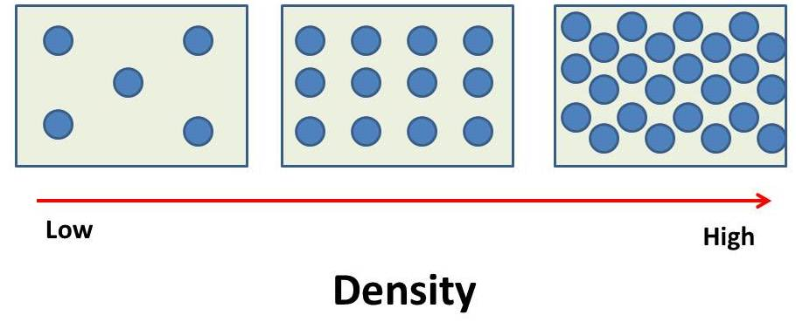

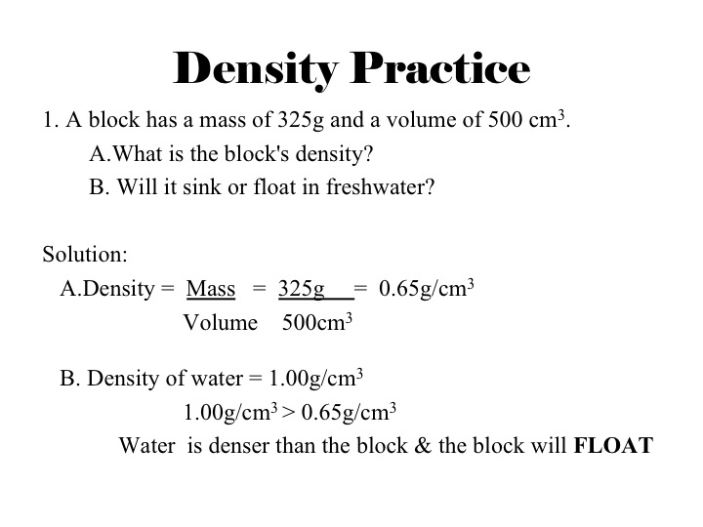
What is the volume of the cylinder in the image?
29ml – 19ml = 10 ml

What is the volume of the ring in image?
68ml – 64 ml = 4ml

