Ch. 8 Review – Plate Tectonics

- What is the theory of continental drift? Who came up with this theory? What was a major concept this theory lacked? (Notes, pg. 172)

- What is the theory of plate tectonics? (pg. 172-173)

- Compare/contrast oceanic and continental crust. (pg. 177)

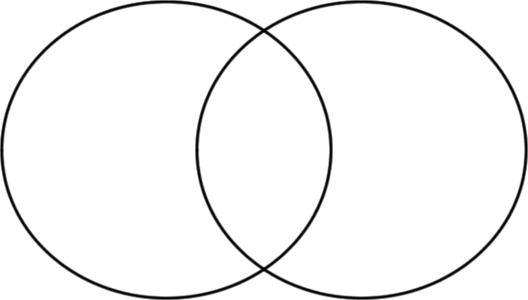

- What are the 3 types of plate boundaries? (Notes, pg. 176-178)

- What type of boundary is responsible for sea floor spreading? (Notes)

- What type of boundary is responsible for creating mountains? (pg. 178)
- What is a Mid Ocean Ridge, how is it formed? (Notes, pg. 174)

- What is a trench, how is it formed? (Notes, pg. 177)

- Which type of boundary destroys crust?

- What type of boundary creates new crust?

- What type of boundary NEITHER creates nor destroys crust?

- How do scientists believe the plates of the Earth is moving? Explain. (pg. 180-181)

- One important piece of evidence to support the theory of plate tectonics comes from the magnetic properties and ages of igneous rocks on the ocean floor. Explain how this helps support the theory. (pg. 174)

