Ch. 3 Review – Models of Earth
- What is the difference between a map and a map projection?

- How does the Mercator projection depict the Earth? What is an advantage and a disadvantage?

- What is a map scale and how do you use it?

- What are lines of latitude?

- What are lines of longitude?

- What is the function of latitude and longitude?
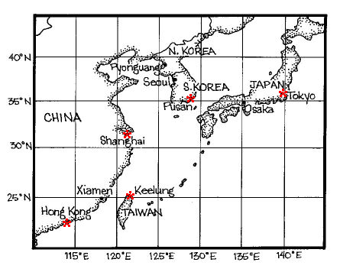
- Using the map to the right, what are the coordinates of Tokyo Japan?

- Using the map to the right, which city lies at approximately 23˚N, 114˚E.

- What is topography?

- Label the following on the picture to the right : contour line, contour interval, index contour

- How would contour lines be spaced if the land had a steep slope?

- How would the lines be spaced if the land had a gentle slope?

- Draw the following symbols and how they would be depicted on a topographic map. River, hilltop, and a depression/crater.

- What is a linear profile and what does it show us?

