Ch. 2 – The Nature of Science
- Why do scientists use the Scientific Method?

- List the steps a scientist would take using the Scientific Method. (Use notes/foldable)

- What is a hypothesis? What are the steps necessary before formulating a hypothesis? (Use notes/foldable)

- Why is it so important for scientists to do many trials for experiments?

- What is the difference between a theory and a law? (Use notes/textbook)

- What does observation mean? (can be found in Daily Words packet)

- What are the difference between an INFERENCE and an OBSERVATION? (Use chromebooks)

- In the scenarios below, identify the following components of an experiment. (Definitions for variables can be found in notes)
  - CIRCLE the Independent variable
  - BOX the Dependent variable
  - UNDERLINE the Constants
Scenario 1 Floor Wax
A shopping mall wanted to determine whether the more expensive “Tough Stuff” floor wax was better then the cheaper “Steel Seal” floor wax at protecting its floor tiles against scratches. One liter of each brand of floor wax was applied to each of 5 test sections of the main hall of the mall. The test sections were all the same size and were covered with the same kind of tiles. Five (5) other test sections received no wax. After 3 weeks, the number of scratches in each of the test sections was counted.
Scenario 2 Perfumes and Bees’ Behavior
JoAnna read that certain perfume chemicals would agitate bees. Because perfume formulas are secret, she decided to determine whether the unknown chemical X was present in four different perfumes by observing the bee’s behavior. She placed a dish containing 10 mL of the first perfume 3 m from the hive. She recorded the time required for the bees to emerge and made observations on their behavior. After a 30-minute recovery period, she tested the second, third, and fourth perfumes. All experiments were conducted on the same day when the weather conditions were similar; that is, air temperature and wind.
Metric Review
- What are the two ways to find the volume of an object? (Use Metric System Foldable)

- What is density? What is the formula to find the density? (Use Density Notes)

- What tools would you use to find the mass and volume of a regular object? (Use Metric System Foldable)

- And what tools would use to find the mass and volume of an irregular object? (Use Metric System Foldable)

- What are the base units for mass, volume (regular and irregular), and length? (Use Metric System Foldable)

- Students plan to use several rain gauges to compare average monthly rainfall on Virginia’s Coastal Plain and Piedmont regions. Which of these is the independent variable?
  - Height of the rain gauge c. size of the rain gauge
  - Brand of the rain gauge d. location of the rain gauge
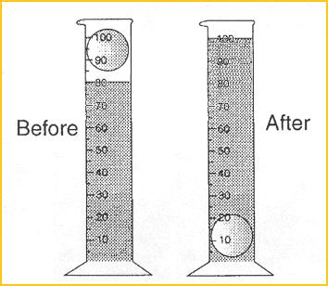
- Explain how to find the volume of the coin, and then tell me what the volume of the coin is.

- A piece of wood that measures 3.0 cm by 6.0 cm by 4.0 cm has a mass of 80.0 grams. What is the density of the wood? Would the piece of wood float in water? (volume = L x W x H)

