Sun Facts
- The sun is a STAR.
  - Compared to other stars, our sun is a fairly average sized star.
- The sun gets its energy from FUSION (as do all stars)
  - Fusion – is the combining of the nuclei of lighter elements to form heavier elements.
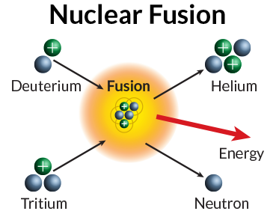
    - Example: 2 hydrogen ions combine to form 1 helium and energy.

Deuterium & Tritium are ions of HYDROGEN

- The sun is neither solid, liquid, nor gas but it’s a PLASMA. This is a fourth state of matter consisting of charged particles: the nucleus contains ions (which have a positive charge) and electrons (which have negative charge).
- The sun is made of layers:
Interior: | Exterior: (Sun’s atmosphere)
Core | Photosphere
Radiation Zone | Chromosphere
Convection Zone | Corona

- Sunspots – dark spots on the photosphere. Some sunspots are barely visible but others are four times larger than the Earth’s diameter!
- The corona gives off a constant stream of electrically charged particles called SOLAR WIND. These particles (protons/electrons) reach the Earth but are deflected by the Earth’s magnetic field. Sometimes these solar winds will cause SOLAR FLARES, which are outbursts of light that rise up suddenly in areas of sunspot activity. They can also cause AURORAS (northern/southern lights), which are displays of color and light appearing in the upper atmosphere due to solar winds reacting with the Earth’s magnetic field. Ultimately our magnetic field protects us from harmful solar particles.
- Two models that describe our solar system:
  - GEOCENTRIC states that the EARTH was the center of the solar system. We now know this is not true.
  - HELIOCENTRIC model states that the SUN is the center of our solar system. This is the theory we now accept.
- Isaac Newton and the Law of Gravitation – Newton developed an explanation for what kept the planets in motion. What keeps the planets orbiting the sun was the force of gravity. The law of gravitation states that every mass exerts a force of attraction on every other mass. GRAVITY – the force of attraction between two objects.

