Ch. 4 Review – Earth’s Structure and Motion

- Draw the layers of the Earth, and list what each layer is made of.

- What is the difference between the asthenosphere and the lithosphere?

- In the Venn diagram and compare and contrast rotation and revolution of the Earth. (Hint: think about what each causes, and how long they take.)

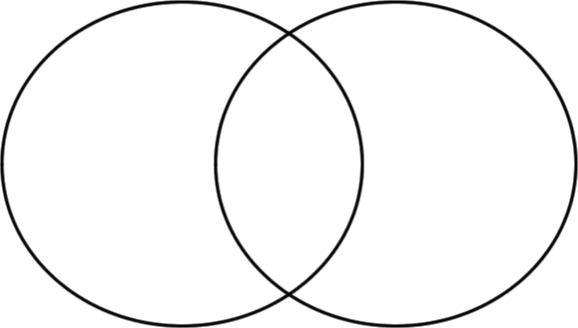

- List evidence that has been found to explain the rotation of the Earth.

- What are the summer and winter solstices? And when do they occur?

- What are the autumnal and spring/vernal equinoxes? And when do they occur?

- How are the seasons in the Southern Hemisphere different from the seasons in the northern hemisphere and why are they different?

- How would increasing the tilt of Earth’s axis affect the amount of daylight throughout the year?

