Ch. 29 – Fossils
- What is a fossil?

- What are scientists that study fossils?

- How are fossils formed?

- What are the different types of fossils?

- What type of rock are nearly all fossils found? _____________________________
- What is relative dating? What does relative dating not tell us?

- What are some of the different principles of relative dating?
  - Horizontality -

  - Superposition -

  - Cross-cutting Relationships -

  - Included Fragments -

- What is absolute dating?

- How do we use radiometric/radioactive decay to determine the age of fossils?

- Half-life is the time required for half a given sample of a radioactive isotope to decay.

Ch. 30 – Geologic Time Scale
- What is the geologic time scale?

- What are the four major divisions of the time scale from largest to smallest?
  - Eon -
  - Era -
  - Period -
  - Epochs -

- What are the 4 major Eras? What are defining characteristics of each?
  - Cenozoic -

  - Mesozoic -

  - Paleozoic -

  - Precambrian -

- Which era above lasted the longest?

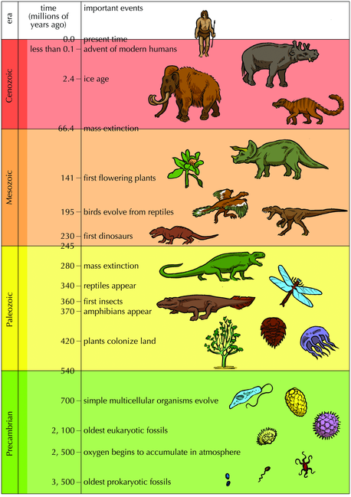
- What gases made up the early atmosphere of the earth? What gases make up the modern atmosphere?

- How old is the Earth?

